Reader-Writer Problem

Enitities:

1. DB – Shared resources
2. We need to fit synchronisation in such a way that at time only one witer can write but multiple reader can read
3. Reader threads – Read
4. Writer Thread – writer | update
5. If > 1 readers are reading , then no issue
6. If > writer OR 1 writer && some other thread (R/W) parallely
   1. Race Consition & data inconsistent
7. Reader reads abcd, in some time writer updates it to abzf, then this makes data inconsistent

Semaphore soln to reader writer problem

1. Mutex – Binary Semaphore
   1. To ensure mutual exclusion, when read count(rc) is updated
   2. No two threads , modify RC at same time
2. WRT – Binary Semaphore
   1. Common for both reader and wirter
3. Readcount(rc) - > integer
   1. Tracks how many readers are there in cs

Writer Solution

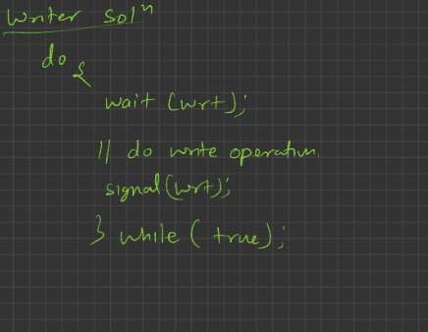

On wait it will lock the task

Then after signal goes telling that the write operation is over

Now new writer can enter the cs

Reader Solution:

